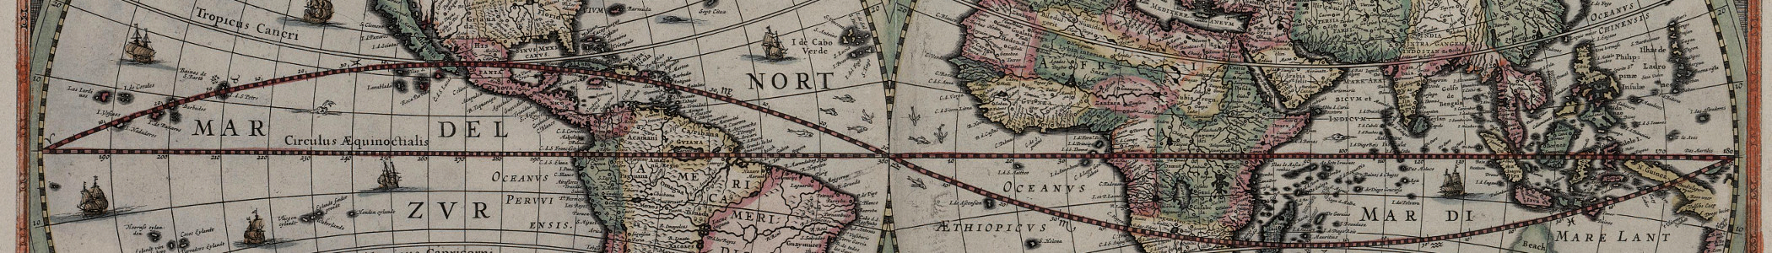
Primary or Secondary Sources?
- A soldier’s diary describing their experience during World War II

- Our history textbook

3. A photograph taken during the 1941 Japanese attack on Pearl Harbor
4. A newspaper article written in 2018 about the end of WWI in 1918

5. A movie about the life of the American President George Washington

6. An autobiography about a President

7. An Egyptian tomb filled with Egyptian writing and artwork

8. The biography of Albert Einstein

Name:
Why is it important to study History? Possible answer:

Primary and Secondary Sources
Give THREE examples of something that can be considered a primary source:
1.

2.

3.

Give THREE examples of something that can be considered a secondary source:
1.

2.

3.
What is History?

What is History?

What is a historian?

What is historical anachronism?
An anachronism is something, or someone that is out of their correct historical time.
What is chronology?
When historians place events in chronological order, they put them in the order that they happened.
Primary and Secondary Sources
What is a primary source?

What is a secondary source?

